Chunguang (Eric) Xie, Jinyue (Mark) Zhu

EE 371

**Final Project: Arcade Game system with audio and camera**

**Abstract:**

For this final project, we decided to practice all the knowledge learned this quarter by implementing a complex system using keyboard, audio system, camera and LED matrix. The overall system consists of two games to play on the LED matrixes, which are game of cart and the classic snake game. The system is designed such that two players can cooperate or compete at the same time using different controls and game display on different LED matrixes. Audio will be used for creating moods for the game, and the camera is displayed on VGA after the game ends to display players’ action in real-time. We will discuss the implementation in the following sections.

**Introduction:**

The purpose of this lab is to practice design thinking principles and effectively use knowledge learned in this whole quarter to build up a complex system. In this final project, we demonstrated understandings on combinational and sequential logic, useful digital components, design thinking procedures and Verilog programming with complex FSMs. We decided to create an arcade game device with two games loaded for two players, which are the game of cart and the game of snake. Two players will be given different control buttons and different screens for the game, and they can cooperate or compete to reach the win. Music will be generated once the users start the game, and the camera will be seen on the VGA once the game is over. Keyboard is used to provide enough buttons for both players. For the game of cart, the game will be displayed on the LED screen with barriers moving all the way from top to the bottom. The cart will be displayed as a red dot and is controlled by the user. For the first user, pressing the KEY[3] will make the cart go left, while pressing KEY[2] will make the cart go right. For the second user, pressing the delete key on keyboard will make the cart go left, while pressing the key page down will make the cart go right. Every time the cart goes through the gap between the barrier, the score will increase by 1 and be displayed on the HEX display. The max score for the game is 999. For the game of snake, it is only available for keyboard input and 1 person only. (We will be implementing a two-player version soon). The controls are assigned as follows: Home button is up, delete button is left, end button is down and page down button is right. The snake can cross the border of the led matrix and appear to the opposite site as starting point.

To implement the complex problem, we first understand the problem statement and think about the modules that I need to create. Then, we created a block diagram to show the relationship between modules and how the problem could be solved based on the diagram. Next, I created each small module and FSMs, tested each one as we go along. Finally, we hooked these FSMs in the game_of_cart.sv , Snake.sv, keyboardDriver.sv along with the music, led_matrix and camera drivers, and tested the whole board using ModelSim and loaded on FPGA for real-world testing.

Throughout this lab, we will be able to understand more about sequential logic, ways to construct useful components and keep following the design steps to solve a complex logic problem in real-world. Finally, we can draw out the schematic, implement it through Verilog, and load the design to an FPGA to test our idea.

**Materials:**

* Altera Terasic DE1-SoC Board with power and USB cables
* Several LEDs, Switches, and wires.
* Breadboard
* PC with Altera Quartus II Lite installed
* Two 8*8 LED Matrixes
* Speaker and microphone
* Camera
* Keyboard

**Game of Cart**

**Design Procedure and Implementation**

In this section, we would discuss the implementation of the game of cart. The led matrix will be used as the screen which will display the cart as a red dot and the barriers as green dots packed up in a row. After the game has started, the barriers will be shifting downwards, while the user must control the cart to dodge through the open spaces in barriers to score points. For the first user, pressing the KEY[3] will make the cart go left, while pressing KEY[2] will make the cart go right. For the second user, pressing the delete key on keyboard will make the cart go left, while pressing the key page down will make the cart go right. Once the cart hit the barrier, the game will be over, and the system will wait for user to restart the game. Specifically, the cart will remain at the current position if no button press is detected. Three HEX displays unit (HEX3, 4, and 5) are used as the scoreboard. It will properly record the score and update it when the cart flies through the barrier maze. In particular, the three HEXs will display the current score as decimal ranging from 0 to 999. SW9 is used for resetting the entire game with both the playfield and score. I added a new functionality that allows the user to change levels based on the SW, which are SW2 to 0. HEX 2 to 0 will display the current level as “Lv x”, x is from 0 to 7.

Understanding what we are implementing, we first think about the modules that we will need and the overall block diagram of the system. To fully use the functionality of the led matrix, we used the module called **led_matrix_driver.sv** which takes care of the connection between the board and the led matrix. Then, we created a module called **cart.sv** that display the cart pattern at the first row using red lights. It is a FSM that will shift to the correct state to display the cart’s position horizontally. To display the barrier pattern, we created a module called **generator.sv** that generate barrier at a certain frequency. To reach a fairly random barrier pattern, we used a LFSR of 10 bit (**LFSR_10.sv**) to produce random numbers as the input for the barrier generator. To demonstrate the action of cart going through barriers, I created the module **shifter.sv** that shifts the barrier from right to left at every clock edge. Since all the barriers use the green leds on the led matrix, it will not have conflict with the red leds used by the cart. The red led array from 1 to 7 are all set to be off. After that, I also implemented the scoreboard using **gamelogic.sv**, **counter.sv** and **seg7.sv**. The game logic module will determine when to increment the score during the game and also determine the state when the game is over (cart hit on barrier). The counter module is paired with a seg7 module so that the counter will increment the score when the input from game logic is true, while the seg7 will properly update the HEX display based on the counter module. Moreover, to add some thrills and functionality to the game, I created the **levelDisplay.sv** that will change game levels based on user input (from SW). In this way, when the SW input is changed, the generator will start creating different barriers based on difficulty. Finally, we can hook up these FSMs through a block diagram, as illustrated below. We also took a photo of the board with the external device (led matrix) being properly wired shown in the Appendix section. The led matrix is actually difficult to wire, and we spent a lot of time on just making the led matrix work. The picture is shown after the block diagram.

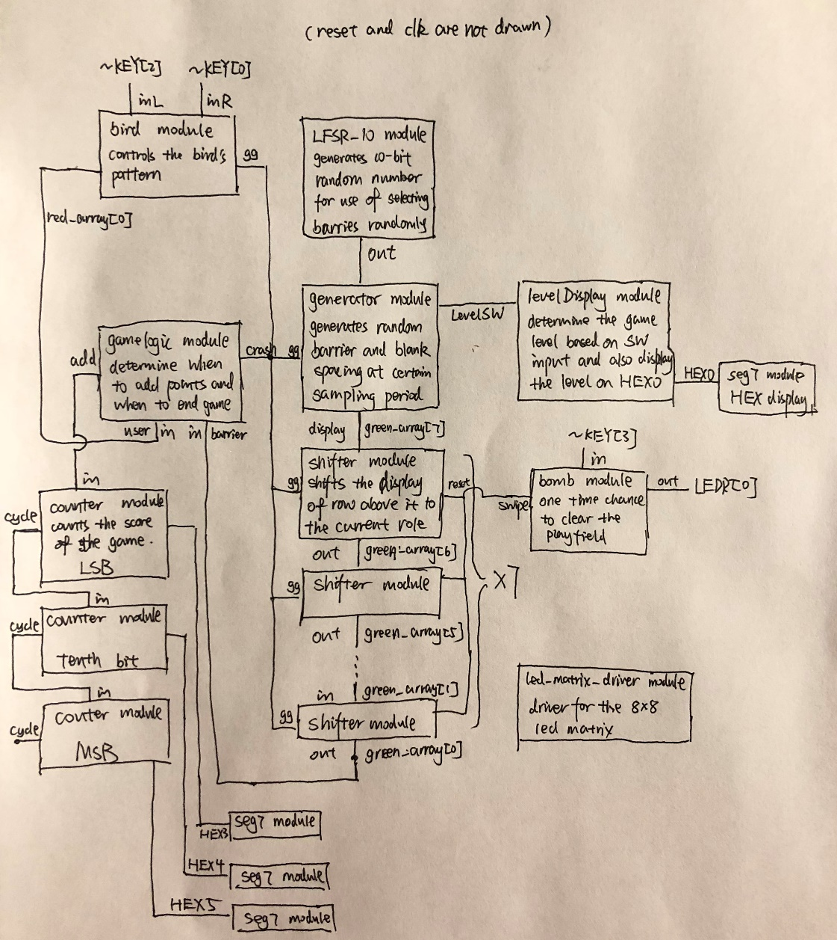

At the high level, this design practices our knowledge on all the stuffs learned in this class, including design thinking, programming on useful components and knowledge on sequential and combinational logic. It also challenges us and helps us practice subdividing FSMs and hooking them together.

Based on the rule of the game, the cart pattern will change based on the user inputs. If no user inputs are present, the cart will just remain at the current position. Otherwise, the cart will move to the left or right based on the input given by user. In this way, the whole game is more stable in terms of display and usability. Because we noticed that the light will change pretty fast based on the previous rule and the user may have a hard time controlling the cart. Moreover, the HEX display will keep track of the score of the game. Hence, this is a sequential logic and we used several FSM mentioned above to solve the problem. Also, we will use the divided clock adjust the pace of the game.

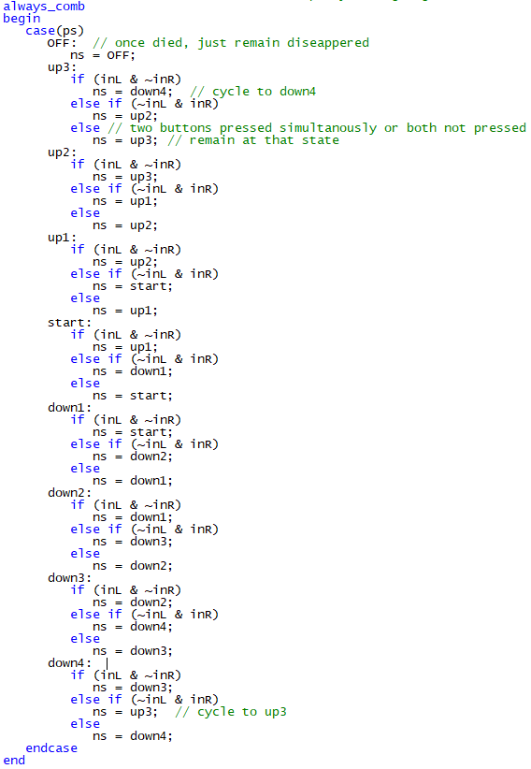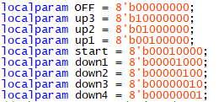The cart module is in charge of controlling the cart pattern at the bottom row of the red led matrix. The inputs are clk (the clock), reset, inL (left move by user), inR (right move by user) and gg (represents game over). The output is one row of the LED matrix, from [7:0]. Because of my selection of states, the output row pattern of the LED matrix just equals the present state. The cart is represented by a red light, while other spots are set to be off. Hence, my local parameters display all the possible patterns for the cart at the bottom row, where a “1” indicates the cart. These local parameters correspond to the patterns of the position of the cart in the row, as shown to the right.

They represent the LED sequence with 1 being on and 0 being off. In this way, I have 9 states that represent all possible patterns on the bottom row based on the game rules. I defined my present state and next state as 8-bit sequences so that they can be in any of the 9 states. Then, I listed out the different cases of my FSM, as shown to the right. The outer loop (condition) is based on different ps. For instance, if the game just started, the row is at “center”. Then, the inner loop (condition) is based on user inputs. So, if no user inputs are detected, the pattern will remain at “center”. If not, if the inputs inL is 1 and inR is 0, then it set the next state as “up1”. All other cases follow the same logic, and I have listed all the ways that the pattern would change. Finally, to make the game more interesting, I set up a cycle pattern such that if the user pushes the cart (red light) off the row, then the light will reappear at the other end of the row. However, if the cart crashes into a barrier, then at the next clock cycle, ps will become “OFF” and the cart light will be off forever unless the player pressed reset. Hence, I adjusted inner loop of “win” state. At the inner loop, if both inL and inR are pressed simultaneously or both are not pressed, then it will just remain at that present state. Because I have chosen the LED pattern as my states, I can just set the output LED row accordingly to the present state for my FSM. Moreover, to deal with the fast clock period (even though at divided clock level 15, the period is still 1/768 s). The led matrix is having a hard time to display properly at this fast pace. Hence, I adjusted my design such that I added a counter (denoted as incr in code) that counts till a certain number of clock edges as one complete sample. Based on that period, I will sample the patterns to make the led display smoother. Specifically, if the counter is 0, then it will let ps follows ns. Otherwise, ps will not be updated.

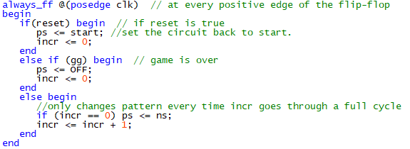 For the DFF, if reset is pressed, the present state will change to “start” at the next positive edge. Moreover, the counter will also be set to 0 to avoid wrong counting. Else if the game is detected to be over, then the ps will be set to “OFF” at next clock edge. Otherwise, it will just be the feedback and follow next state only at the counter (incr) cycles through one cycle. I also wrote out the testbench for this module. The simulation result is shown in the result and analysis section.

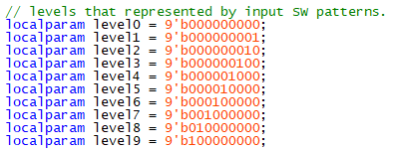 The generator module will generate barriers at certain frequency. Between the generating periods, it will create blank barrier (a row of all OFF led) to help make the game smoother and easy to play. The inputs are clk, reset, gg, [8:0] levelSW, [2:0] in, while the output is [7:0] display. The gg corresponds to the gamelogic module’s crash function, where it will be 1 if the game is over, otherwise 0. The [2:0] levelSW are the new functions that I add to the game, where it will allow user to adjust difficulty by changing the SW. The 3-bit in is selected from part of the output of the 10-bit LFSR, such that it will create a fairly random pattern for the input, which will be used as generating barriers. The output display corresponds to one row in the LED matrix, and to be more specific, the output will be the top row of in the matrix. Similar to the cart module that deals with the display of LED matrix on a fast clock, I added a counter (denoted as incr in code) to readjust the sampling frequency. Instead of creating patterns at every clock edge, I only created new patterns after certain multiples of clock edge. In this case, I choose to be every 2^9 clock period. To generate blank barriers, I make my generating period twice long compared to the shifting period. I also added a logic “temp” that constantly shift from 0 to 1 and to 0 on the sampling period, such that when temp is 0, I will generate a new barrier pattern, but when temp is 1, it will create a blank pattern. Because my shifting period is 2 times faster, it will shift twice for a given pattern, thus making the barrier look like a real barrier (with a width of 2). And the temp will make the pattern change from barrier to blank and back to barrier. After setting up the sampling period, I added some local parameters to denote the game levels. Then, in the next state logic section, if the game is over, then everything will just freeze. If the temp is 0, then I will allow the present state to follow a new barrier pattern. Based on the case of levelSW, it will then select the barriers from that level specified. The inner most loop contain the cases of input, so that I can create a fairly random pattern of barriers. If the levelSW are not the same as the parameters listed, it will just go into default and treat it as level 0. It makes sense, because I want to make the game really easy when the user are toggling switches to change levels. There’s no point in distracting users or making the game harder at this time. To hook the display with the FSM, I directly let the output be the present state.

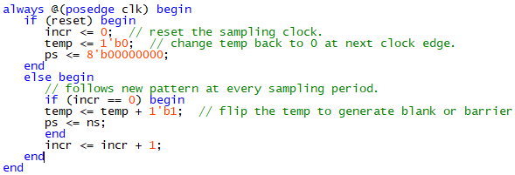For the DFF, If reset is pressed, the present state will change to “8’b00000000” at the next positive edge of the clock. Moreover, the counter will also be set to 0 to avoid wrong counting. Else if incr is 0, then I will allow the “temp” to change from 0 to 1 or 1 to 0, increment the counter and let ps follows ns. The alternation will create the overall “barrier – blank - barrier” pattern. Otherwise, counter will be incremented without letting ps following ns. I also wrote out the testbench for this module. The simulation result is shown in the result and analysis section.

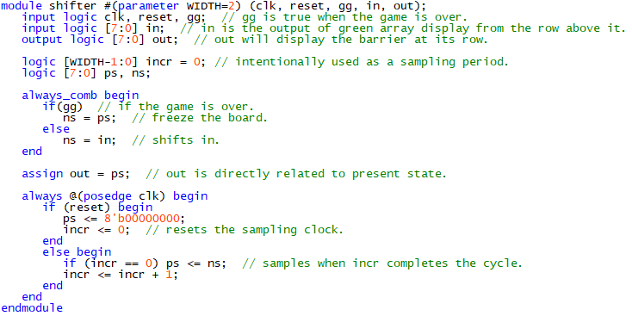The shifter module will shift the barriers from the row above it to itself. The inputs are clk, reset, gg, and [7:0] in, while the output is [7:0] out. Based on previous discussion, gg is used to freeze the game when the game is over. In this case, when gg is true, as shown in the next state logic, it will let ns equal to ps, hence freezing the game. [7:0] in is the row display above the current role, thus reaching the effect of shifting. Similar to the cart and generator module, I also created a counter to deal with fast clock issues. It will sample and change present state at half of the time as the period for generating new barriers. If the game is not over, ns will always equal to in, thus allowing the shifting functionality. I hooked the output to the present state to properly display the shifting. For the DFF, If reset is pressed, the present state will change to “8’b00000000” at the next positive edge of the clock. Moreover, the counter will also be set to 0 to avoid wrong counting. Else if incr is 0, I will let ps follows ns and increment the counter. Otherwise, counter will be incremented without letting ps following ns. I also wrote out the testbench for this module. The simulation result is shown in the result and analysis section.

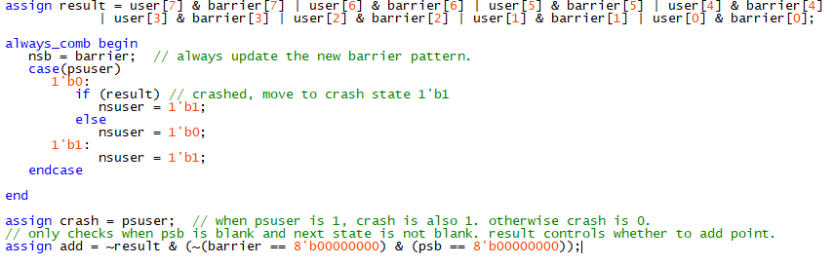The gamelogic module determines when to add points and when to stop the game. If the cart passes through a barrier, the score will be incremented by 1. When the cart crashes on the barrier, the game is over and will wait for reset. For this module, the inputs are clk, reset, [7:0] user and [7:0] barrier. The output is the add and crash, which denotes adding points and ending game respectively. To properly keep track of the game behavior, I created [7:0] psb, nsb to keep track of the behavior of the barrier. Also, we created psuser and nsuser to trace the cart’s position. Because we are always determining the game logic at the bottom row of the led array (where the cart will interact with the barrier), we assigned “result” to be as shown below. In this way, it will be 1 when the cart crashes the barrier (when the cart and the corresponding place at barrier are both 1). For the next state logic, we let the barrier be continuously shifting, while the psuser (cart) will change states based on the value of “result”. The crash logic is determined by result, where the psuser will permanently stay at 1’b1 if the game is over. By assigning crash to psuser, it properly defines the crash logic, with 0 representing alive and 1 denoting game over. For incrementing points, we considered the possible cases of barrier input. Because we created blank spaces between the barriers generated, we don’t want to increase points when the cart fly through a row of blank LEDs. After that, we want to increment points only when the cart successfully flies through the barrier. Only when the current state of the barrier is 8’b00000000 and the next state is not 8’b00000000 (denoting the upcoming of a barrier), we want to increment point if the result is not 1. We will not be increasing points in other cases (ps = blank, ns = blank or ps = barrier, ns = barrier or ps = barrier, ns = blank). Hence, We assigned add as shown in graph to make the system only add points when the cart goes through a barrier.

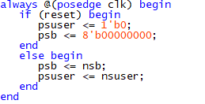Finally, as shown above, we also adjusted the DFF. If reset is pressed, the present state of user will set to “1’b0” and psb will be set to “8’b00000000” at the next positive edge of the clock. This change corresponds to wiping up the playfield. If reset is not true, the present state will just follow the next state. We also wrote out the testbench for this module. The simulation result is shown in the result and analysis section.

We also wrote up a seg7 module for the final project. Four-bit inputs are taken as the “code” for the HEX pattern and the module outputs the seven-segment display based on the code. Depending on the different cases of bcd, the seven-segment display will be displaying different number. Due to the active low property of the HEX display, we have inverted the display configuration to get the correct display pattern for the HEX. In particular, we listed out the “code” we need for the final project. To keep track of the score of the game, we need to HEX to display from 0 to 9. All other cases are set to default. The flow of logic of this module is shown in Appendix. We also wrote out the testbench for this module. The simulation result is shown in the result and analysis section.

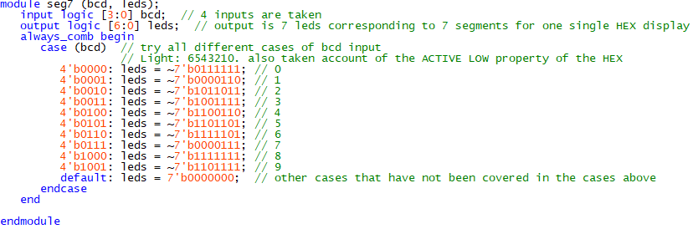

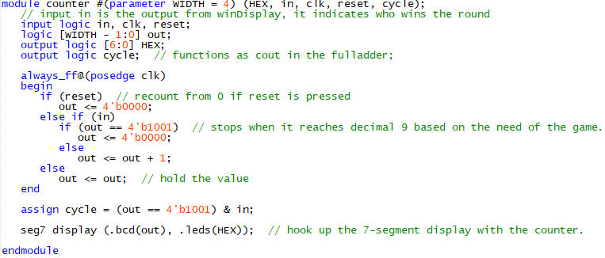 The counter module oversees the scoreboard. It will properly hold or update the score during the game. Because the game needs a count from 0 to 999 in decimal, I need three HEX displays for each digit. For each digit, a counter should be able to increment value from 0 to 9 and then cycle back to 0. To implement that, I used a logic [WIDTH – 1: 0] out as the score keeper. 0 to 9 has exceeded three bits range and hence I have to use a 4-bit counter. However, I don’t need all the combinations of 4-bit values and I only need 4’b0000 to 4’b1001 to represent 0 to 9. All other cases are classified as default in the seg7 module. For the counter, once the input is true, it will increment the out by 1. In particular, when the out is currently 4’b1001 (decimal 9), I will force the next state to be 4’b0000 (back to zero). When the input is not true, the counter will hold the value, and if reset is pressed, out will be then set back to 4’b0000. After linking up the seg7 module with the counter module, I also implemented the carry out so that the 3-bit decimal will change correctly (for example, from 009 to 010 and from 099 to 100). Basically, I followed the same concept used in building the 4-bit full adder, and hence I added an output “cycle” for the counter module. The cycle will be one only when the out is currently at 4’b1001 and the input is true (denoting the bit’s change from 9 to 0, and hence a carry out is produced). This cycle will become the input for the tenth bit, as we all know that the second bit will only increment when the LSB is changing from 9 to 0. (009 to 010, 019 to 020). Similar logic is used for the MSB, where the input to the MSB is the output cycle of the tenth bit (middle bit). The output cycle of the MSB is discarded, as we don’t need to wire it to anything. I also wrote out the testbench for this module. The simulation result is shown in the result and analysis section.

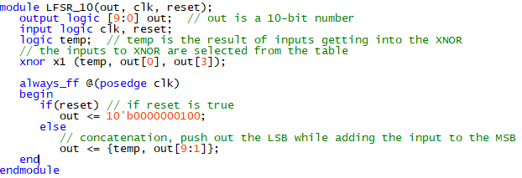THE 10-bit LFSR module oversees generating random numbers that are later used as input for the barrier generator. The module consists of 10 DFFs in series, where the output of DFFi is the input of DFFi+1. The input to the DFF1 is the XNOR of output of DFF10 and DFF7, as I checked through the table. By picking the bits to XNOR carefully, I get an FSM that goes through a fairly random pattern, but with very simple hardware. The inputs to the XNOR gates of my design are chosen as indicated in the table at the end of the lab manual. Moreover, to represent the shifting property, I use concatenation to update the signal pattern. And to make the barrier more varied at the start of the game, I change the reset pattern to 10'b0000000100. I also wrote out the testbench for this module. The simulation result is shown in the result and analysis section.

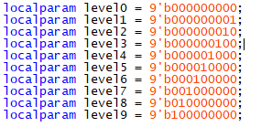 The levelDisplay module is in charge of displaying the game level that the player is currently at. The result is shown as a digit from 0 to 9 on HEX0. This module is purely combinational, and it takes input clk, reset and levelSW, while the output is HEX. The levels are designed to be adjustable by the user, such that the user can manipulate the SWs to adjust the level at any time. Because I have taken SW[8:0] as input, I listed out the game levels as parameters, and in this way I can correlate the “code” to certain level. After getting the code, I hooked this module with seg7 display so that the HEX will be showing the correct output based on the “code” given. Other than the levels 0-9 listed to the right, the other combinations of SW patterns are also taken care of. When the SWs are in those patterns, the level will display 0, and I have also adjusted the barrier generator such that it will create barriers of difficulty 0 to create a “buffer” for the user, until they turn the SW back to another difficulty level. I also wrote out the testbench for this module. The simulation result is shown in the result and analysis section.

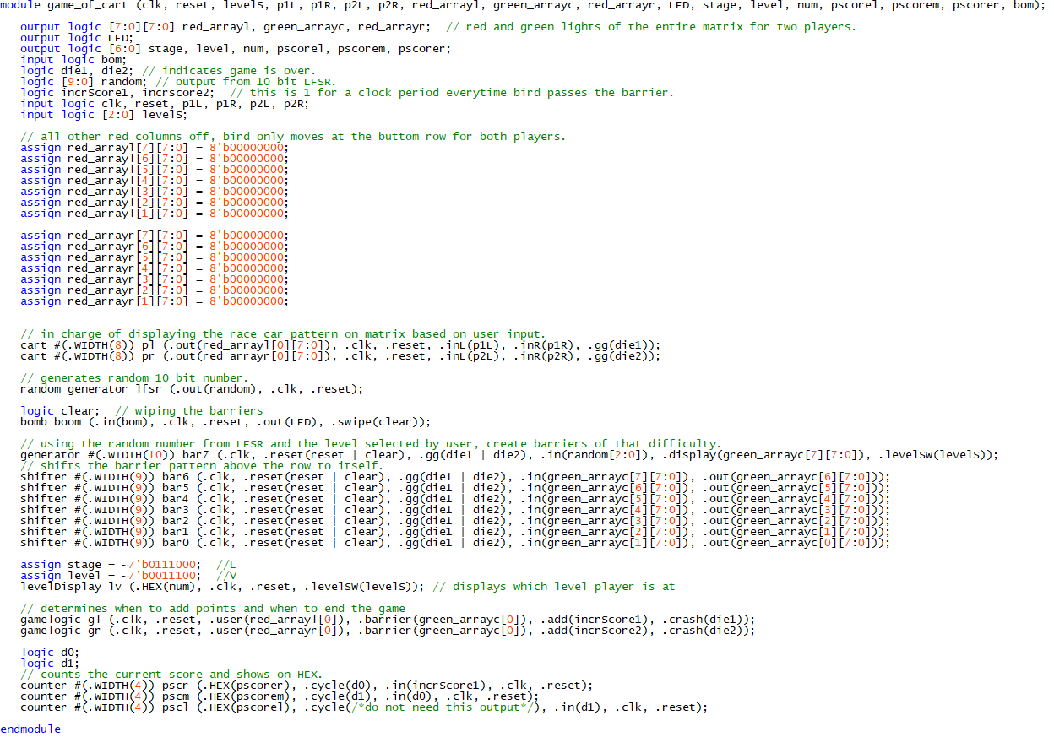The led_matrix_driver module is directly used from the tutorial. Since it works as a driver and has been tested to be functioning, I didn’t need to illustrate this module with great detail. Finally, I wrote up the top-level module. The overall game_of_cart module will take in clk, reset, levelS, p1L, p1R, p2L, p2R as inputs, while the HEX, 2D arrays representing the led pattern are outputs. I set up the clock using the divided clock module. To fully set up the board with these FSMs, I also configured the reset and hooked up module’s inputs and outputs. In particular, we made this a two-player game, so we have four user inputs controlling two carts, while we instantiated some of the modules (cart, gamelogic) twice so that we could create different patterns for the two players when playing the game. Lastly, the green array is used by same users as we wanted both users to challenge the same difficulty to make the game more interesting.

**Results and Analysis**

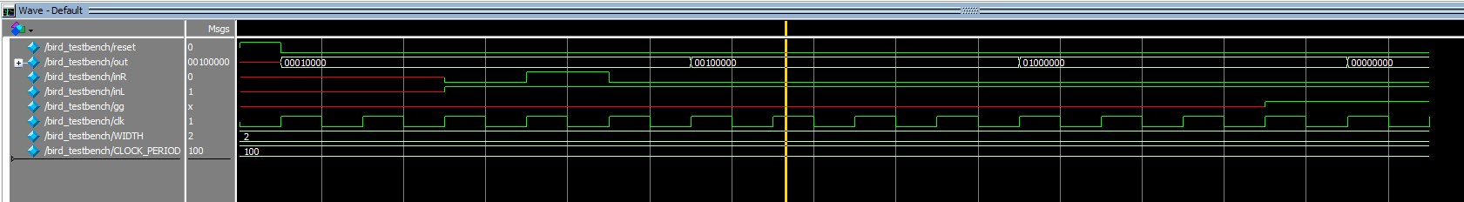The simulation result of cart.sv is illustrated below. This module worked properly, as I directly observed the simulation. Because I created my own sampling period, for testing purposes, I change the parameter to 2 such that every 4th clock cycle, the pattern would change. From ModelSim, after reset, in this case with no user inputs, the state is correctly shown as 00010000, which corresponds to “start”. Then, if only inR is true, the state will remain in its current state. If both inL and inR are pressed or with no user inputs at all, the state will remain at the current ps. After that, when inR is 0 and inL is 1, and at the 4th clock cycle, the pattern changes to 00100000, which is the cart moving left. Finally, when the gg is 1, meaning the game is over, the game effectively changes pattern to 00000000 at next clock edge. So, this module behaves fine.

The simulation result of seg7.sv is illustrated below. This module works fine, because in the ModelSim, it is showing the correct output based on the input given. For instance, when the input is 4’b0000, the seven-segment display should display “0”. Because of the active low property of the HEX, I have inverted the result. As another example, when the input is 4’b1001, the HEX should display “9”. If the input is the default case, then the HEX should display “0”. As illustrated in the ModelSim, the inputs are paired with the correct inverted version of the seven-segment display.

The simulation result of generator.sv is illustrated below. This module behaved good. Without user inputs, the output remains to be 00000000. Because I created my own sampling clock, and for testing purposes, I change the parameter to 2, so every 4-clock period, the generator should generate a new pattern. Because I also use temp to create the blank pattern between two barrier patterns, you can see in ModelSim that there’s a 00000000 between each barrier patterns that last for 4 cycles. I also set levelSW to the parameter corresponding level 0. The inputs are correlated with the output, as manifested in the waveform. And when gg is 1, ps will always follow ns and the board will be frozen, as shown in the 00000000 at the end. Other cases also prove the code is working, as shown below.

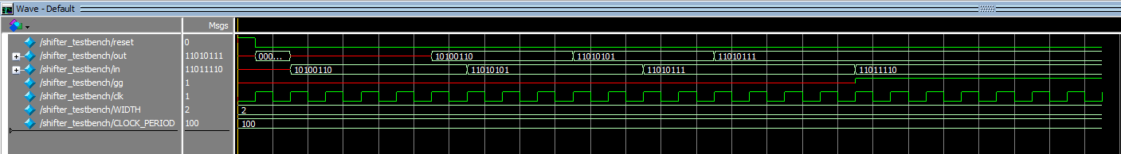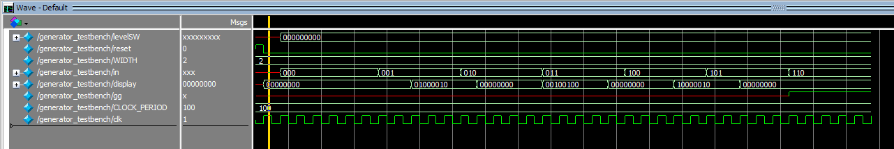The simulation result of shifter.sv is shown below. I also used my own sampling clock and I set the parameter to be 2. Hence, every 4th clock period, the shifter will shift the input. After reset, the output is 00000000 as expected. Then at the sampling edge, the input is 10100110, then after 4 clock edge, the output correctly displays 10100110. Moreover, when gg is 1, which means game is over, the shifter stops shifting and the output is frozen, as illustrated at the end of the output waveform. Other cases also show that this module is working correctly.

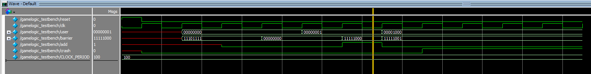The simulation result of gamelogic.sv is shown below. This module works, because the ModelSim is displaying the correct outputs. For instance, when user is 00000001 and barrier is 00000000, then the crash should be zero. At the same time, because the barrier is blank (not valid barrier), then the output add should also be zero. However, when the user (cart) is 00000001 and barrier is 111110000, now the barrier is valid, and the cart didn’t crash on the barrier, hence the output add becomes 1. Finally, when the cart crashed, the crash is 1 ever since until reset and add is 0. Other cases also show that this module is working nicely.

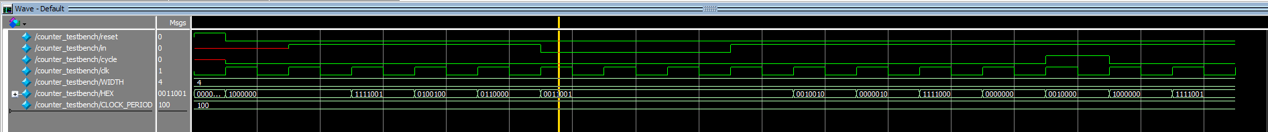The simulation result of counter.sv is illustrated below. This module works, because the ModelSim is displaying the correct output. For instance, I mandatorily set the counter to change back to 0 after it reaches 9. As shown in the waveform, when the HEX is displaying 9, if the input is true, at the next clock edge, cycle will be 1 and HEX will be displaying 0. Moreover, when reset is pressed, the output HEX will remain to be off until reset is released. Then, when the input is 1, the counter will add the score by 1 and also display the correct HEX pattern.

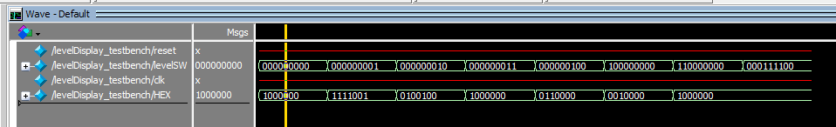The simulation result of levelDisplay.sv is shown below. This module works nicely based on the result from ModelSim. Because the module is purely combinational, I tested several scenarios with a time delay of 10ns in between. For instance, when the levelSW is 9’b000000000, the “code” should be 4’b0000 and the output should be HEX displaying “0”, which is 7’b1000000 in binary. If the levelSW is not in the case listed in the module, then all of these cases go to default, and the output should display “0” on HEX. These cases are all correct, as shown below.

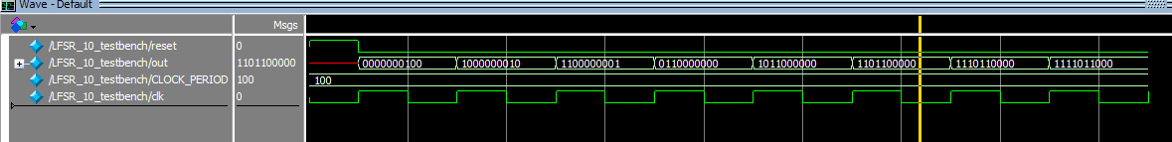The simulation result of LFSR_10.sv is illustrated below. This module also works. After reset, the out should be 0000000100. Then, based on my implementation, the input to the LFSR is the XNOR of out[0] and out[3]. Since they are all zeros, the input is 1. Because of the shifting property, the last bit (out[0] is shifted out or disappeared, with the input carried in as the first bit). Hence, at the next positive clock edge, the pattern changes to 1000000010. Because out[0] and out[3] are still zeros, I can deduce that the next state will be 1100000001, and the simulation manifested my idea.

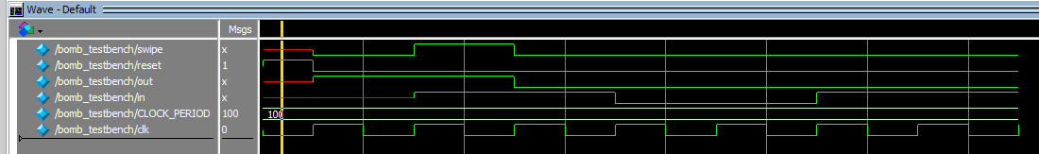The simulation result for bomb.sv is illustrated below. After reset, out is 1 which is as expected. Then when the input is true, then at the next clock edge, out is 0, and hence will make the LEDR[0] to be off. At the same time, swipe is 1 for that clock period. After out is 0, no matter what the input, out stays at 0. Other cases also demonstrate that this works perfectly fine.

After making sure all the modules are behaving fine, I combined them in DE1_SoC.sv and instantiated the correct ports to the modules. Then, I powered on the circuit board, and it was showing the correct sign. We can demo this part to the TA. Upon testing, there is no error in this module.

The flow chart for the game_of_cart module is shown below.

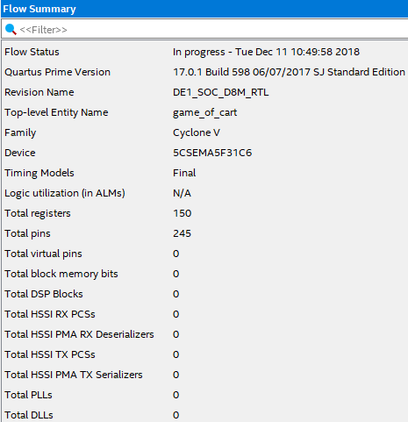 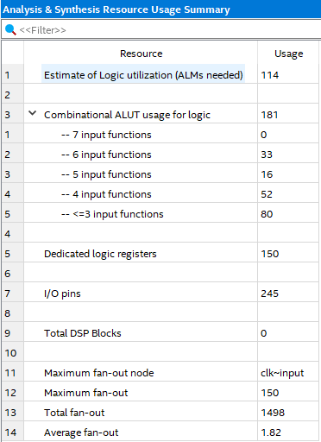

**Game of Snake**

**Design Procedure and Implementation**

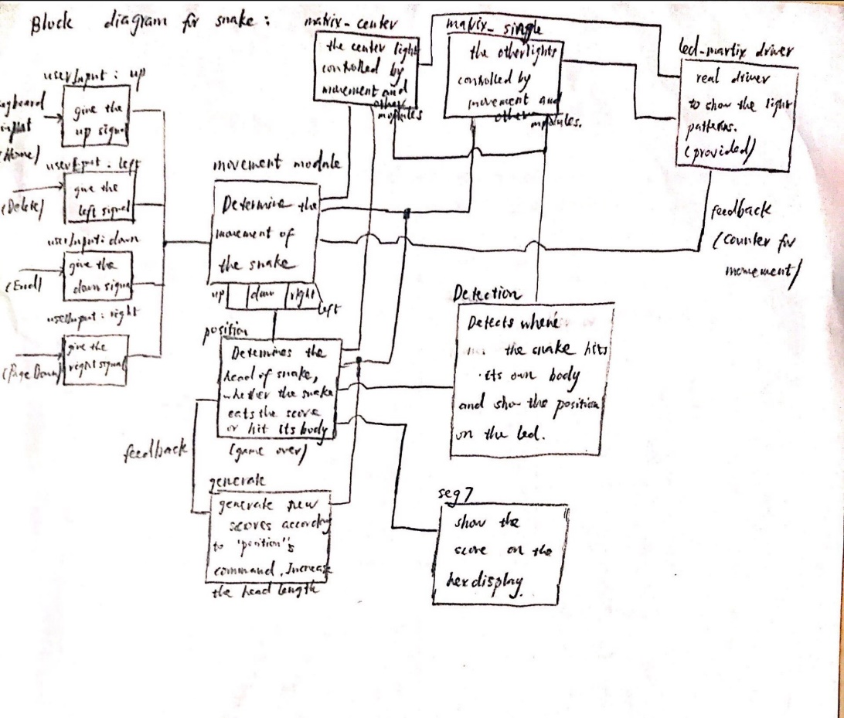In this section, we would discuss the implementation of the game of snakes. The snake is the second game that will be introduced here. After the player choose to reset and to start a new game, they are granted the freedom to change from Flappy Bird to this game. In this section, I will briefly introduce the features and functions of each module in this snake game, and finally I will show some simulation results and resource utilization entity. Here’s the overall block diagram for the snake design, and I will explain explicitly about how and what each module does its work.

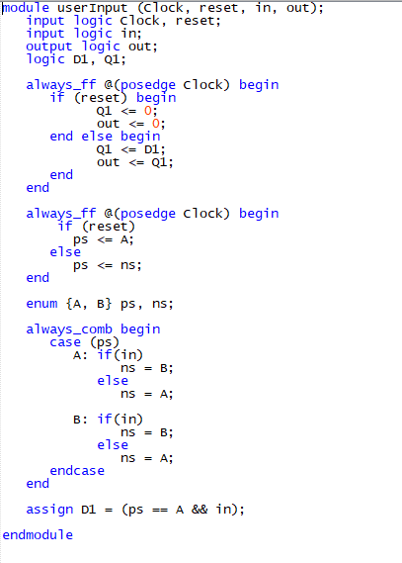To begin with, the snake game takes in four input directions, which are controlled by the controller (We used the keyboard as the input to this single-player game). The game’s reset is SW[6], for the whole system’s reset, it is the same as the Flappy Bird. The first module is the “user input” module, which is shown in the right. This module basically handles the problem that if the user holds the button, the system would continue to receive a ‘1’ signal. To deal with this, we just used the module that we had in 271 that is the button is pressed and then released, the system would get a ‘1’ as input. Otherwise the system would receive a zero. This module transfers the user input and give the command to other modules.

For the overall game logic, I choose to give a signal to each led on the led matrix, which means that there would be 64 lines of code that takes in two nearby leds and one opposite border led. Specifically, I’ll introduce the matrix_center and the matrix_single modules. These modules are similar to what we had in 271. The normal light and center light module, however this time we used them to implement the led matrix logic.

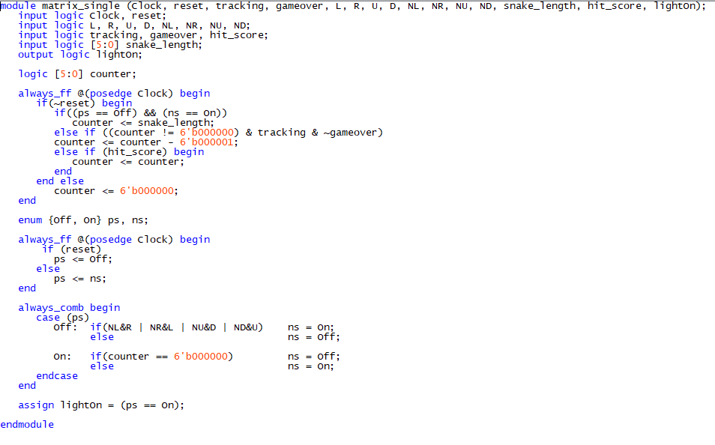

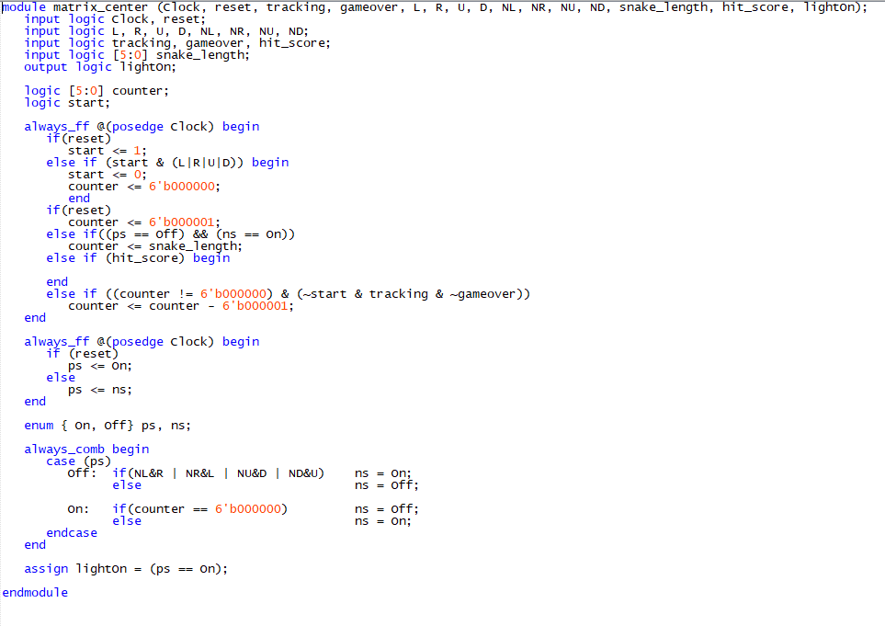

The tracking signal is given by the other modules that I would talk about in the next part, and its function is to tell the counter inside this module to decrease by one if the game is not over, and also for determining if the snake hits its own body in later part. The 6-bit counter is specifically designed to count the length of the snake and controls the on and off state od each led light in case of that the user got score and add a new light. The L, R, U, D are the moving directions given by userInput module, and the NL, NR, NU, ND are the input signals represents conditions of nearby led lights. The Snake-length is given by other module which represents the current length of the snake. Finally, the lightOn signal tells whether this led light should be light up or not. One difference between center light and normal light is that the extra parameter justreseted, which determines the start of the whole game and resets the counter.

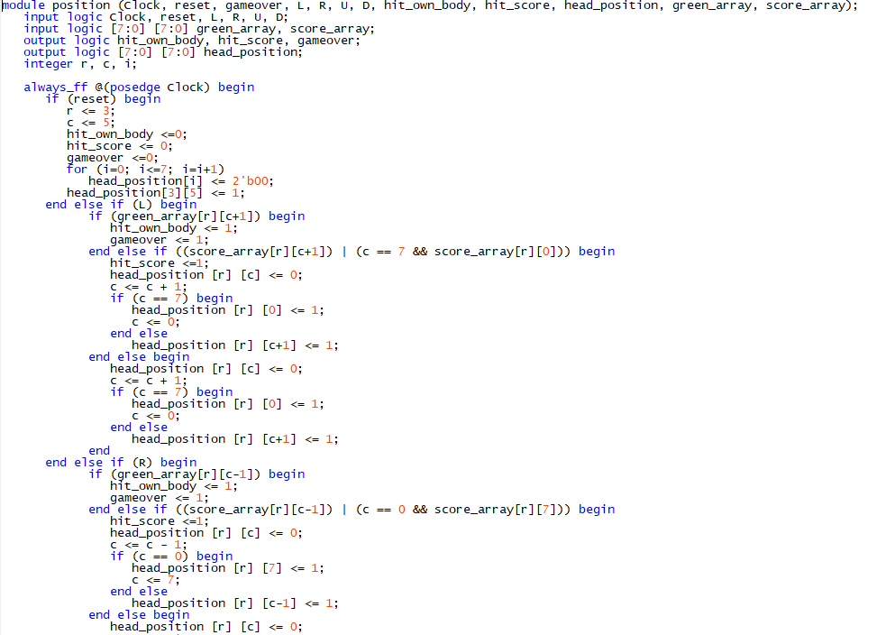

The position module shown up here is designed to determine the head position of the snake by determine the r parameter (row) and the c parameter(column). When reset signal is ‘1’, the head of the snake is implemented to be at (5,3) position on the led matrix. The logic of this module is that when the system receives the directional input (L,R,U,D), and then detects the next led to the left of the current one. If the next led is the score, the it would give the hit_score signal. If the next led is the body of the snake, it would give the hit_body signal. Also, if the head reaches the border, it would appear on the opposite side of the current led.

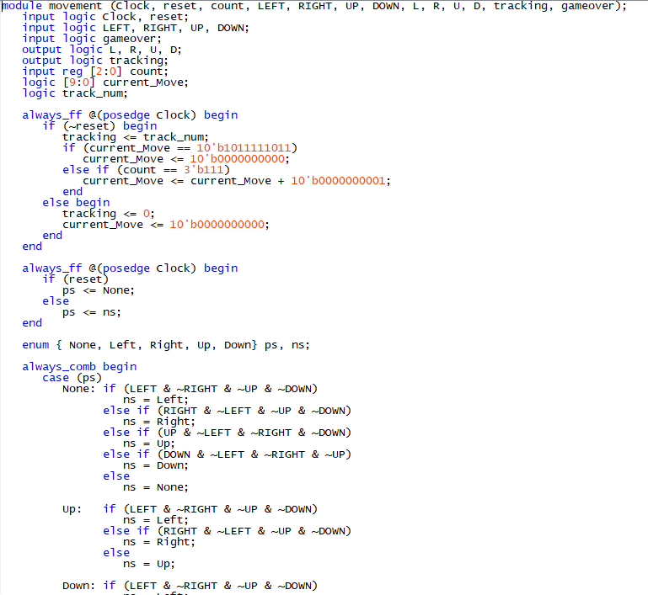The module to the left is designed to give the correct direction for the snake movement, also use a second counter to generate a very big number to for keeping the direction for the snake. This means that if the direction was chosen by the player, the snake would always go in that fixed direction. This module also generates a signal called ‘tracking’, which signals that the snake had moved, the matrix_simple and matrix_center modules receive that signal and decrease the counter in that module to elongate the length of the snake by letting the corresponding led lights up for a longer time.

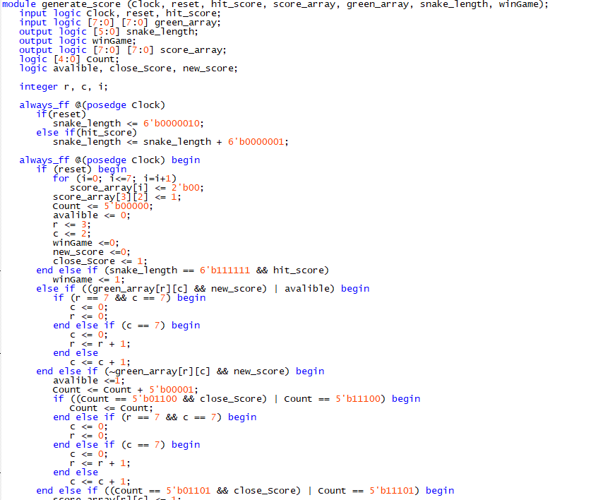

The generate_Score module take in the snake’s led data and the hit_score signal to determine where to generate a new score. Also, it would output the current snake length. By looping through each light in the led matrix, it would generate a new score (controlled by the new_score signal) at a position where it is not occupied by the snake body. In addition, if the newest score is generated too close, it would choose a new position which is far away (not applicable if there are only a few spaces left. And this process is controlled by the close_score signal). Finally, if all the places are taken up, this module would give a ‘wingame’ signal which stands for the success of the whole game.

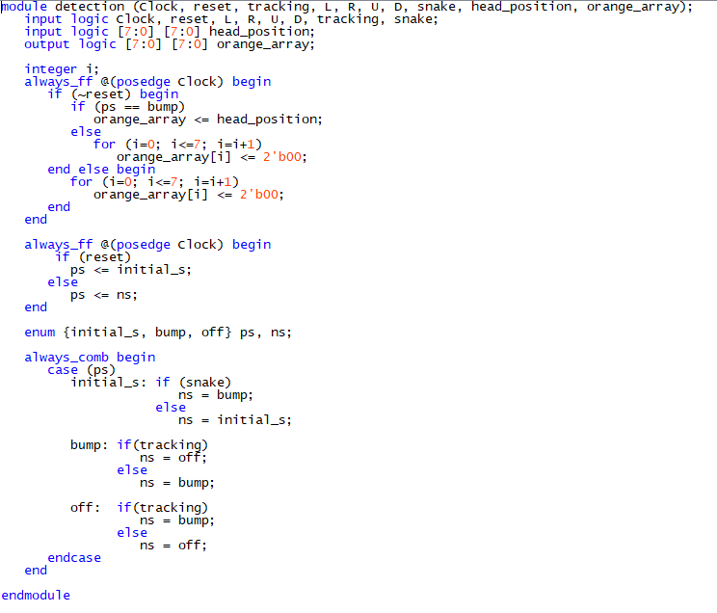The final module is the detection module. This module takes in the tracking signal, which stands for a new movement of the snake. If the one movement toward the body happened, the next state would be bump, however, since the player would have the chance to change the direction at the last minute, there’s buffer state which is the off state. If there’s no way back, then it would light up the orange light, which means that the player had bumped into the snake body. If it happened, that particular position would turn to orange and the game would be over at the same time.

And finally, here’s a part of the overall top-level module. The seg7 module was the one we used in 271 labs to show the results.

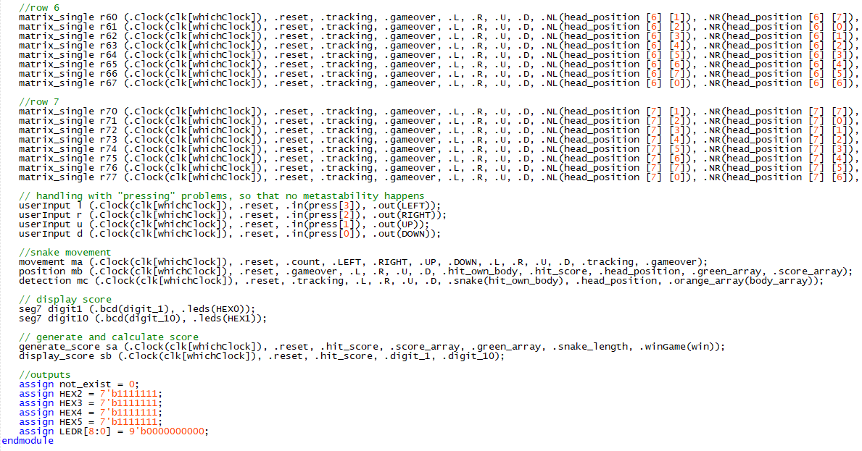

Here’s the flow summary of this part of snake design:

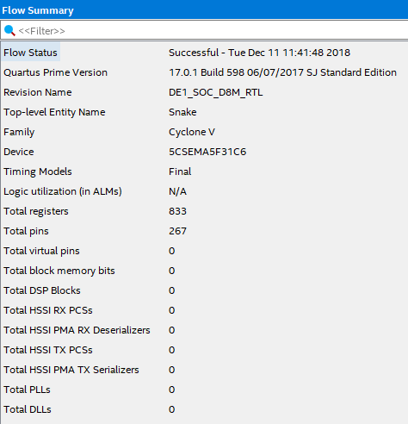 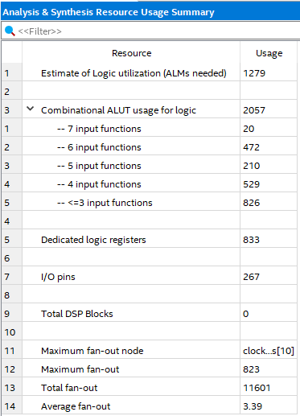

**Results and Analysis**

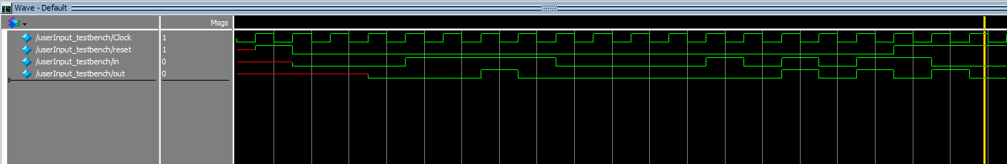The simulation result of userinput.sv is illustrated below. This module worked well. When the input signal is always ‘1’, there would only be a short period of time for the output to be 1. This is designed that player must press then release the button either on keyboard or on the KEYs on FPGA. When the input is like a square wave, (pressed and then released), we expect the output to behave like the same. And according to our waveform, we got it correct.

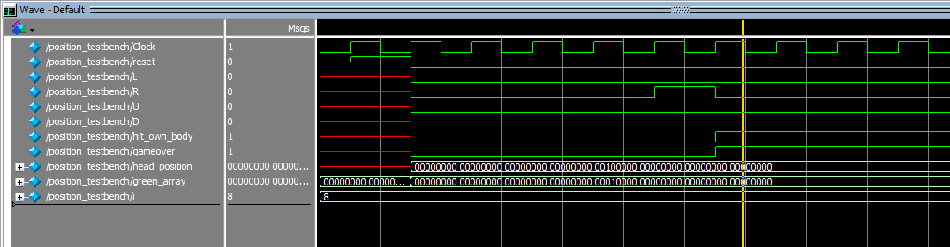The simulation result of position.sv is illustrated below. In this testbench, we specifically set a barrier (snake body) at position [3][4] and the head is in position [3] [3]. When we press the right button, the snake should be crashing the barrier and the expect result is the output signals ‘hit_own_body’ and ‘gameover’ should be ‘1’. As seen from the waveform, the result was the same as the expected result, which was perfect.

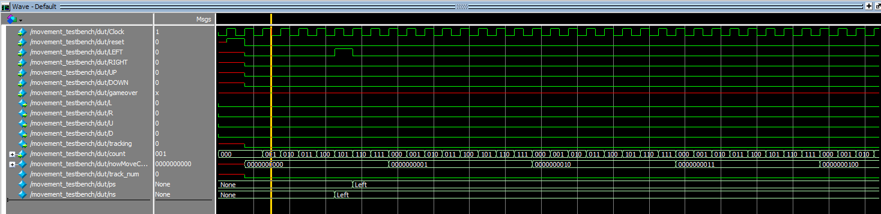The simulation result of movement.sv is illustrated below. This module behaved good. Since this module takes in the ‘count’ signal directly from the led-driver module, we have to manually add the count by 1 each clock cycle. The movement should be the same until the inner counter ‘nowMovecount’ becomes a very large number. This is specifically designed to maintain the current direction once the player pressed and then released the button. For the simulation result, When we press once the left button, the state shows that we are currently in ‘LEFT’ state, and when the counter counts up enough, the correct ‘L’ is given, which is just what we expected from this module.

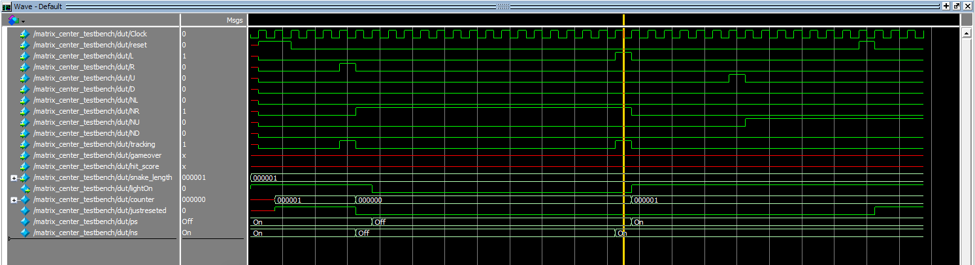The simulation result of matrix_center.sv is shown below. For this module, when we set the output from movement ‘R’ to 1, and ‘tracking’ to 1, which means that we want the snake to go right, we would expect that the center led would be off since from the start(reset) the center light should be off. And the result showed that when just released (the just release signal), the center led would be on (lightOn signal), when the right signal is given, it would be off. This is exactly what we expect for the output. For another set of test, when the light to its right lighted up, and we give a left signal to the snake, we would expect the current led to light up. According to the simulation, the current led indeed lighted up on the next clock cycle. This module worded just as expected.

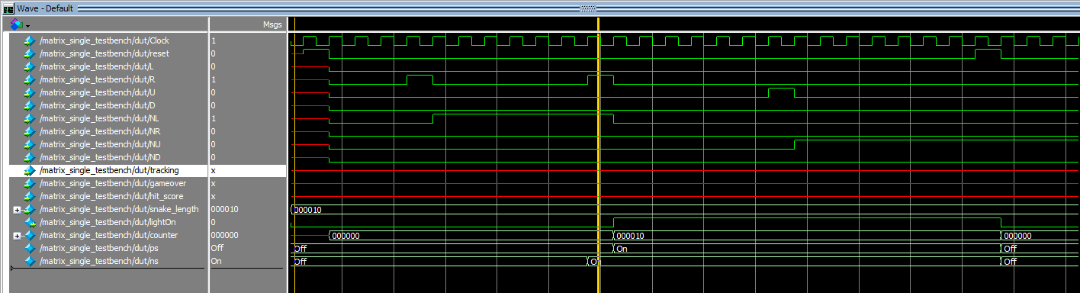The simulation result of matrix_single.sv is shown below. This module works, because the ModelSim is displaying the correct outputs. For instance, when we only give the signal ‘L’, the light would not be on since the NR should be one when L is 1. When we give ‘L’ and ‘NR’, which means that the right light near the current light is lighted up and the direction is left, we expect that the light should be on at next clock cycle. According to the result we had from the simulation, ‘lightOn’ signal is actually 1 next clock cycle, which is really good. Another test is about reset, the expected result was that when reset, the light should be off. And the simulation result was also correct.

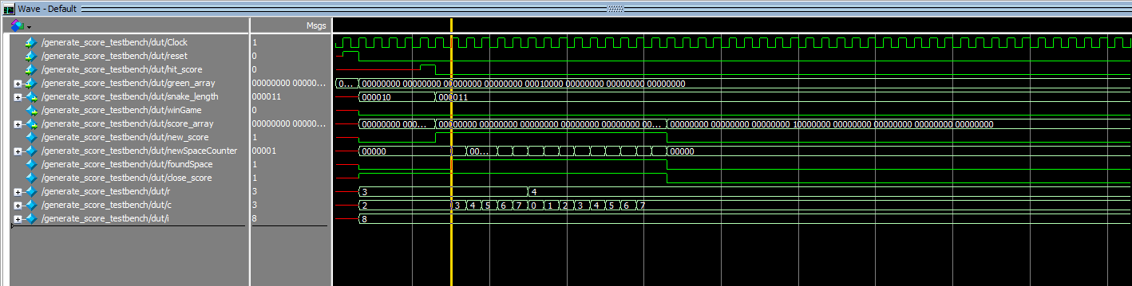The simulation result of generate_score.sv is illustrated below. This module works, because the ModelSim is displaying the correct output. For instance, when we set the hit_score signal to be 1, which means that the snake successfully ate a score, the expected snake length should add 1, and the new_Score signal inside should be 1, also the system would loop through the whole matrix to find new applicable places for the next score to generate. According to the result that we had, when the snake successfully got a score, the snake length indeed increased by 1, also, the new_Score signal and the ‘foundspace’ signal became 1 after the snake ate the score. These results are what we just expected, and the changing r and c parameter shows that the system was really looping through every led light in the matrix, which was also correct.

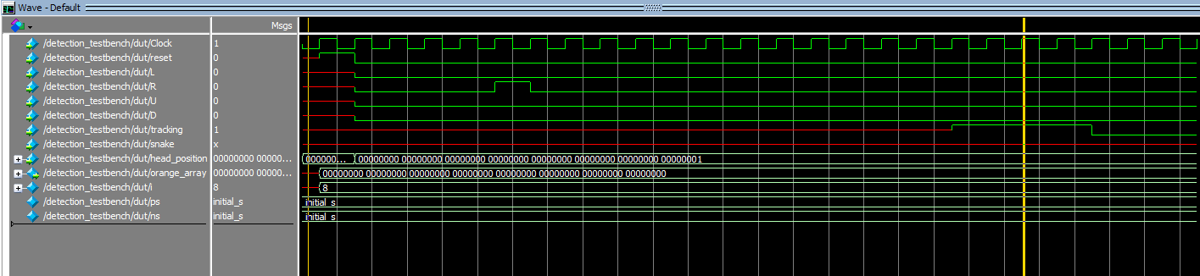The simulation result of detection.sv is shown below. This module works nicely based on the result from ModelSim. Since this module is only used to detect where the head of the snake is when the game is over (the snake hits its own body), we expect that in this module, if we do not give the hit_body signal, it would always stay at initial state. According to our simulation result, the system really staed in the same initial state as we did not give the ‘tracking’ signal nor the ‘hit_own_body’ signal.This module worked just as expected.

After making sure all the modules are behaving fine, I combined them in Snake.sv and instantiated the correct ports to the modules. Then, I powered on the circuit board, and it was showing the correct sign. As implemented in the Verilog file afterwards, the player inputs are the keyboard buttons that I choose (Home, Delete, End, Pagedown). The reset is SW[6], while the HEX are functioning correctly.

**Modifications:** Unlike typical game of snake that only works within the boundary of the led matrix, we created breakthrough by allowing the snake to run through the boundary and appear on the other side.

**Lessons Learned:**

* Check for SystemVerilog syntax whenever I got stuck in programming.
* Remember to select the file you want to compile as the top level in Quartus before compiling.
* Remember to have a clean format and disconnect the board from power when not using it.

**Overall (description) Controller for the Entire System**

**Design Procedure and Implementation**

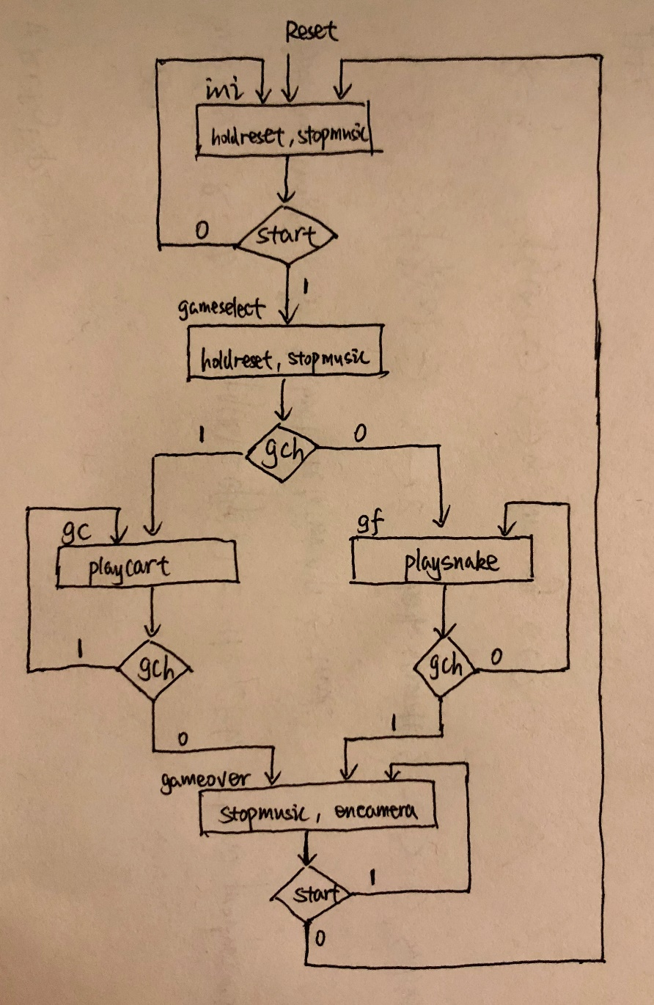In this section, we would discuss the implementation of the top-level controller. It is a FSM with 5 states, where ini represents the initial idle state, the gameselect is the state for user to select between two games, the gc represents game of cart, while gf represents game of snake. Gameover is the state where the users don’t want to play anymore or want to play the other game. The control signals to the other modules are illustrated below. Because we wanted to play music only when the users are playing game, hence we created a signal called stopmusic where it works the same as reset and is sent into the music module. Only when ps is at gc or gf, stopmusic is false. To properly display the game on the led matrix, we created signals playsnake and playcart to denote the display of led matrix. Holdreset signal is used to keep on resetting led matrix when the user is at initial or gameselect state. In those cases, the matrix is just assigned to be off, yet the results from the last game may still be on the board. If we don’t include the holdreset, when the users play another game, they will observe the last match result on the led. Hence, we sent this signal to the game module to enable reset functionality. Lastly, encamera is the signal sent to the camera to enable VGA output on the screen. It is only activated when the game is over. During this time, the system will be at state gameover and the users are asked to see their condition on camera. The ASM chart with control signals is shown to the right. And the code for the controller is shown below.

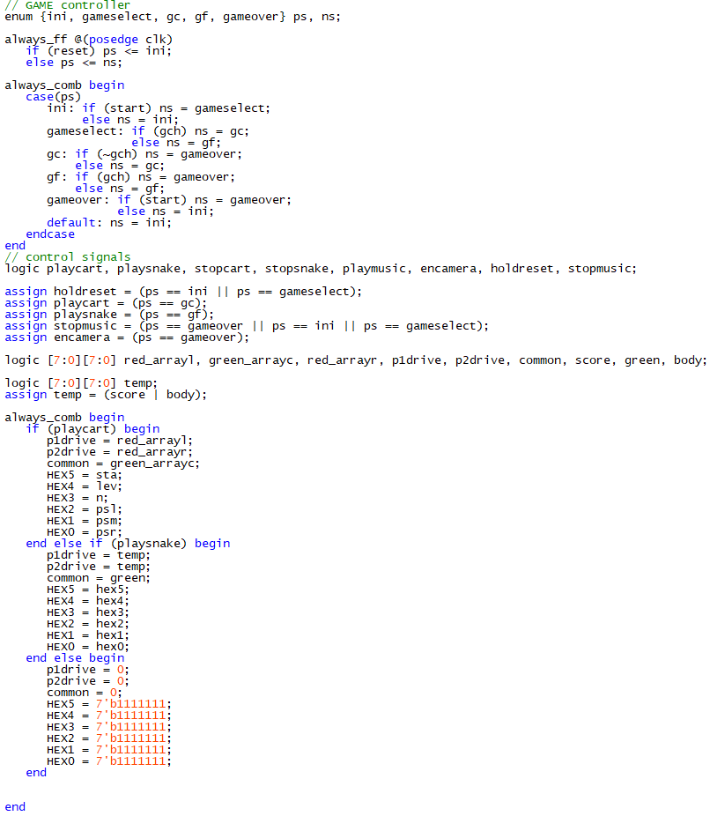

**Audio System**

**Design Procedure and Implementation**

In this section, we would discuss the implementation of the audio system. Because we had a lab on audio (lab5), we adapted the code we wrote so that it would be suitable for the purposes for the final project. In particular, the system will play music when the players are playing the game. So instead of using KEY[0] as the reset and control for the playing music (used in lab5), now we used an internal signal generated by the controller to indicate when to play music and when not to play. In this way, we managed to make the system smarter and only play music when users are playing games.

In the top-level module, I called the music module as follows. Because I wanted to play music only when the users are playing games, I added a stopmusic signal sent by the controller so that when the users are not playing, the music module is kept resetting thus produced no sounds. (The controller module is already illustrated in previous sections).



Within the music module, I followed similar design from lab5, except that we deleted the noise generator because it is not useful for this final project. As shown below, we used an averaging filter to improve the music quality, and we maintained the other wirings.

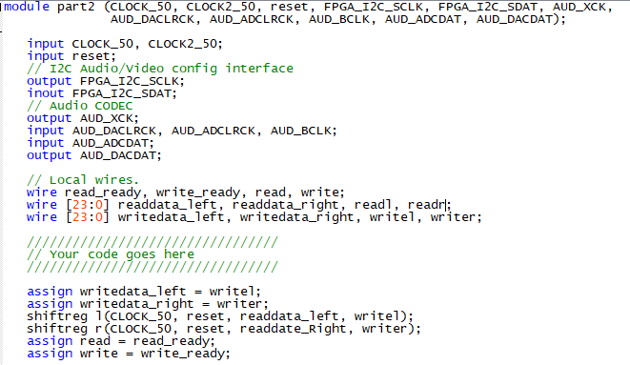

Lastly, we showed the averaging filter module below. The concepts and implementation for this module are illustrated in lab 5, and we have already demonstrated its functionality to the TA.

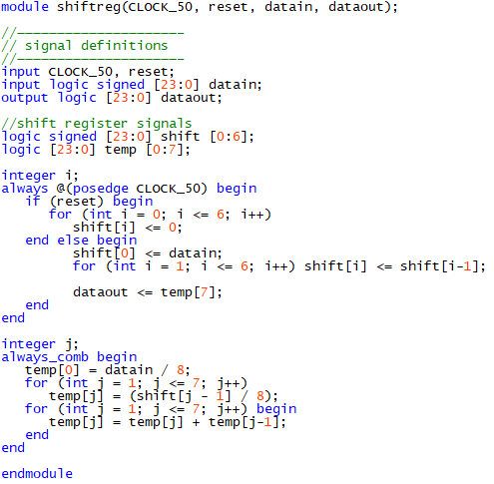

From the testbench of this averaging filter module, it is clear to see that the implementation is correct. The simulation code and waveform for the shiftreg module is shown below.

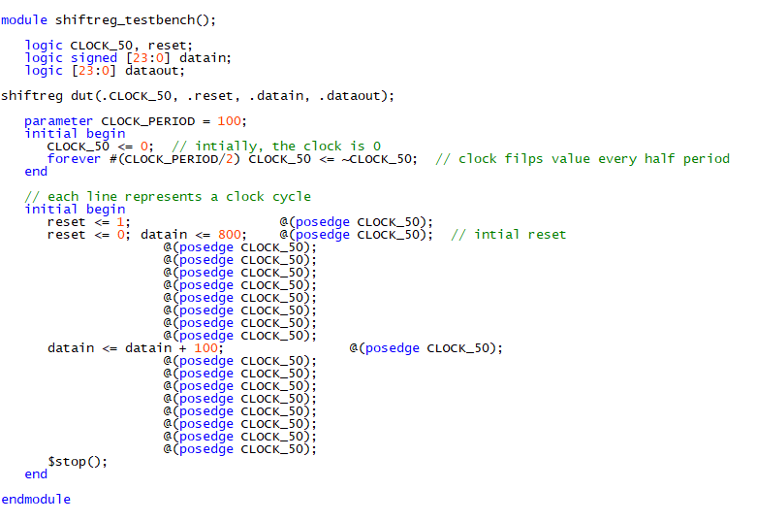

To test with noise, we manually added 100 to our first test case of input 800, which was 900. The simulation waveform was shown down here:

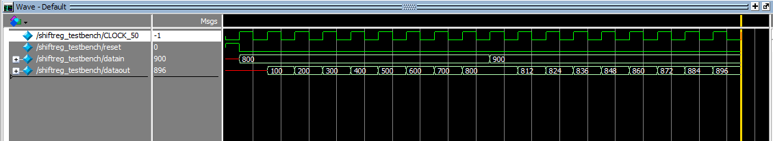When the input was set to be 800, we expect the output to be 800(exactly the same after 8 clock cycles). Because for each 800 to divided by 8 and then added up 8 times, the result should be the same. And this is how the average filter works according to the specification provided in the lab manual. As seen from the waveform, at the 9th clock cycle, the output was exactly the same as input, which was correct.

For noise, we tried to add a noise 100 to the original input for testing. The expected value should be very close to original input according to the algorism provided. As shown in the waveform, the output after another 8 clock cycles was 896, which was fairly close to 900, this showed that we successfully removed the effect of noise.

**Camera System**

**Design Procedure and Implementation**

In this section, we would discuss the implementation of the camera system. Based on the initial starter kit provided, we added the functionality of 30% grayscale, grayscale and completely black scale as real-time filters for the camera system. We used most of the parts given by the starter kit, and we modified the system with the following changes.

Grayscale effect: According to the algorithm for computing gray color in terms of RGB, the following formula is used: **Gray = 0.299 * R + 0.587 * G + 0.114 * B**. As you can see, the weight for the GREEN takes huge percentage in the color mixture. Because 0.587 is about twice of 0.299 and five times about the 0.114, then the major factor in creating a grayscale image is the assignment of GREEN. Hence, with this idea, we implemented the grayscale real-time filter as follows.

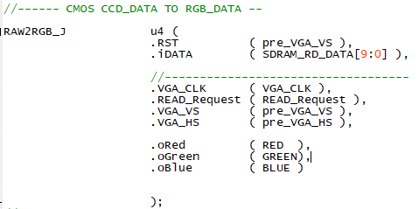

Because SDRAM works as the frame buffer for the VGA controller, and the final RGB outputs are generated using VGA controller, we made the following changes based on these facts. The wire RED, GREEN, and BLUE represent the converted RGB data from the CMOS module, then instead of directly feed these signals to the VGA via the VGA controller, we added an always comb logic with cases (controlled) by switches to indicate what filter we wanted to have in real-time. Finally, we created three more wires of 8-bits to select between the filter we want, and we connected these three wires as the RGB data we want to display on the VGA.

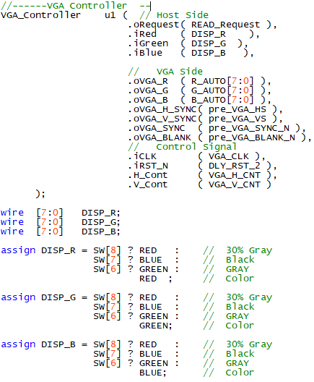

Black scale effect: This follows the similar concept as the previous grayscale one. For the implementation, it is already discussed in the previous paragraph. We would demonstrate this part to the TA.

Finally, within the filter module, we used the direct approach and didn’t select variable delay filter, because that made the output a little bit of blurry.

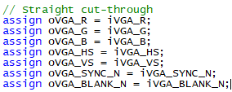

**Keyboard Setup**

**Design Procedure and Implementation**

In this section, we would discuss the setup for the keyboard.

Based on what we had in the project introduction manual, we implemented the keyboard as input to one of our games. Firstly, we tried the initiation file that was given, which was the file that let users press any button on the keyboard and the corresponding code that shows which button was pressed would show up by lighting up the led on FPGA. After our first trial, we observed that key 1 represents ‘16’ in hexadecimal. Then we concluded that our key board used the second set of scan code, which shows down here:

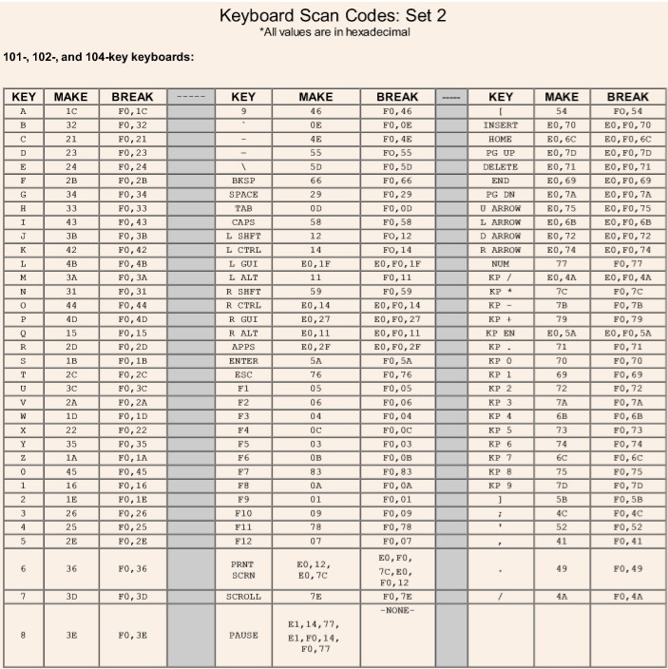

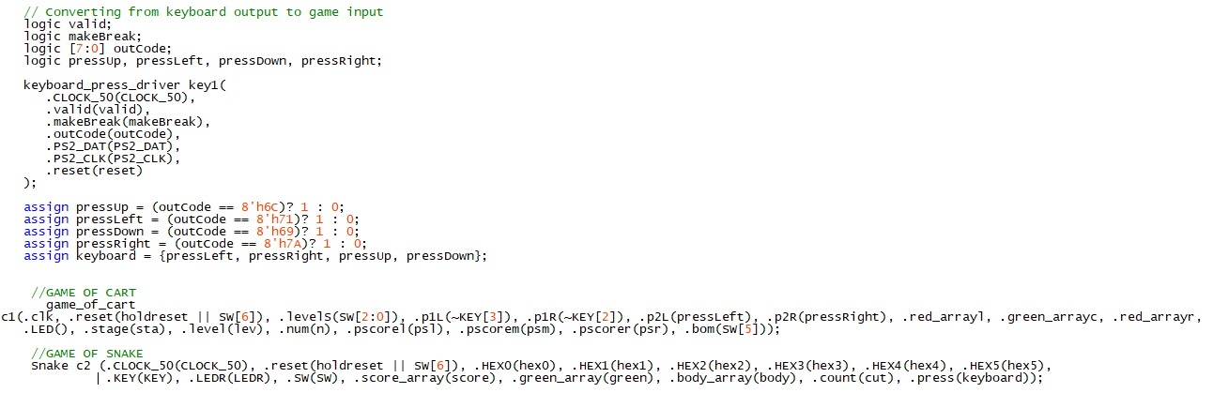 Getting the scan code was crucial to our design. After this procedure, we just need to develop a ‘controller’ which helped to hook up the input to the game. However, for actual implementation, we found out that the given driver for keyboard could not stop sending signal. In other words, it was not suitable for us to use the keyboard for the flappy bird game since in that way the bird would always be moving. However, it worked for the snake game since the snake needed to be constantly moving. Therefore, we just set up the keyboard for the snake game. In addition, the original KEYs on FPGA were not suitable for the snake. Hooking up the keyboard made the game easier to play. Here’s how we actually made the controller using the provided modules:

By assigning the input to keybord, we could control the movement of the snake. ‘Press’ is the array that contains the up, down, left, right signals from the keyboard and transmit those data into the snake module. This part was done fairly quick since we were already given the driver files for the keyboard.

**Total resource utilization**

I also found the number of FPGA logic and DFF resources used. I used 5959 FPGA logic elements and I used 3600 DFFs.

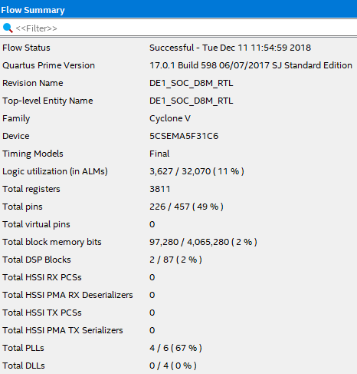 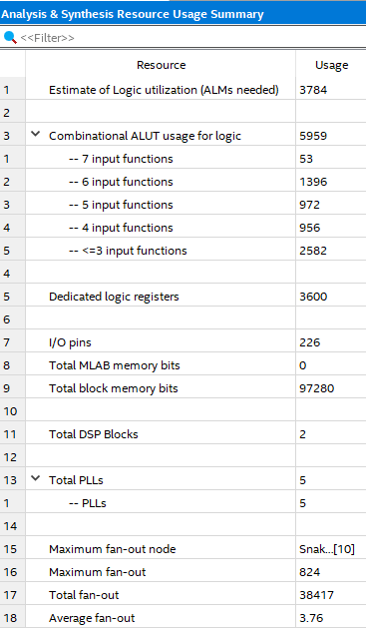

**Modifications:** We modified the camera module to take in all game modules, the music module and the keyboard module. Still, I considered memory usage and implemented the solution with that part in mind.

**Lessons Learned:**

* Check for SystemVerilog syntax whenever I got stuck in programming.
* Remember to select the file you want to compile as the top level in Quartus before compiling.
* Remember to have a clean format and disconnect the board from power when not using it.
* Remember to check input output parameters, and the corresponding type.

**Conclusion**

Based on the knowledge learned on previous labs, we effectively used them to build a complex system with two arcade games and the combination of audio and sound. The inputs to the system are the keyboard, which has been set up using the correct driver and design logic. The output of the entire system includes led matrix, speaker and VGA screen. User will interact with the game on led matrix, hear music from the speaker while they play and observe the camera filming them once the game ends. For the two games, they are both built up from smaller modules and demonstrated concrete understanding on design logic and sequential logic. See the corresponding section if you have questions regarding the game.

The report shows the flow of our design. We first dived deep to create the two arcade games, and after testing both games work fine, we connected the audio module and camera module with VGA to make the system more fun. Lastly, we changed the user input to keyboards and satisfy the system requirement for the final project.

This final project deepened our understandings on digital circuit design and made us become more familiar with sequential logic and programming with SystemVerilog. By adding modules to implement complex functionality and modeling previous modules to fit in the need for this lab, we get to understand deeper about how digital components can be used and the way to connect FSMs. It was really fun. Moreover, the incorporation of audio and camera system let us realize the wide applicability of FPGA and the realm of knowledge that lies ahead. Lastly, this final project let us pay attention to the memory and resource usage. The consideration of power consumption and efficiency is also an important aspect in digital design. The waveform in ModelSim was helpful in debugging and comparing results, and in sequential logic simulation, it is helpful to set the gridlines in wave display to line up with the edge of the clock. In short, these tasks were helpful, and thanks a lot for this awesome quarter.

Hence, the final project demonstrated knowledge of design thinking, creating block diagrams, logic gates, control path and data path circuits, sequential logic analysis, clock and reset mechanisms, advanced Verilog statements and programming skills, all of which we have learned during lecture. Through the final project, we got better understanding on the class materials and wrapped up our learning with this awesome final project. Though it is painful to work on this whole thing for two and more weeks, we got more experienced with the material involved in this quarter and now the system works really great as shown in the video!

Thanks a lot for the help and support this whole quarter. We really appreciated it. It has been a wonderful time learning digital logic knowledge and practicing it. Have a great winter break!

**Appendix**

The photo for the led matrix wiring is shown below. We followed the EE271 tutorial about this. To enable the two led matrixes to display different pattern, we connected different GPIOs to the red_array signal of the two matrixes. It is a cumbersome process and require extensive work and checking, but we are glad to seen it working correctly.

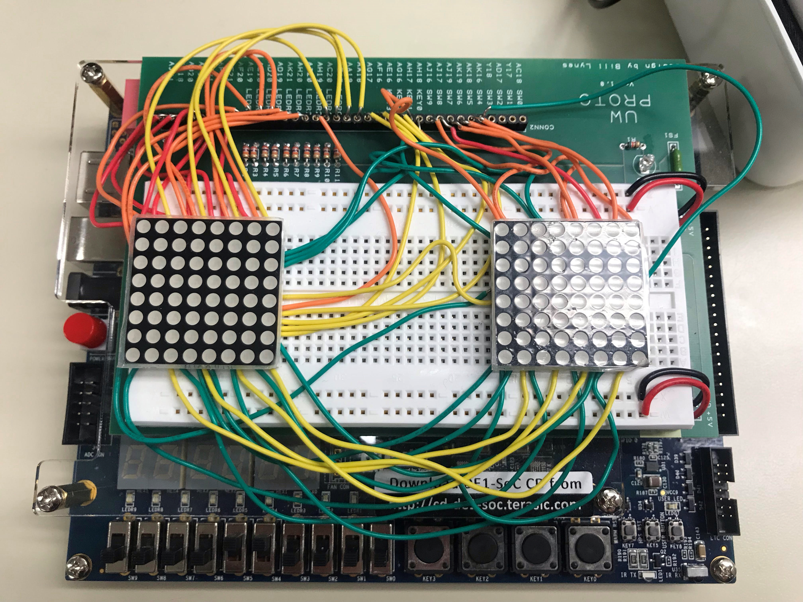

The following shows the drivers we used in the lab.

1. Led_matrix_driver

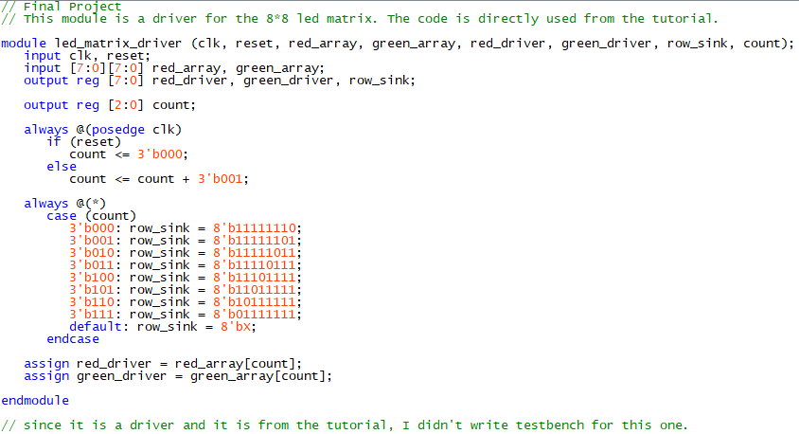

1. Keyboard drivers

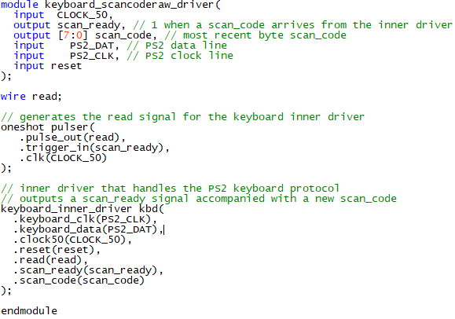

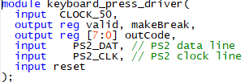

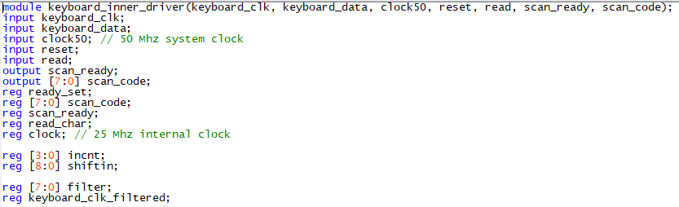

1. Camera driver (top-level module)

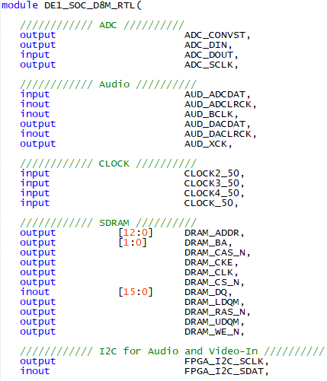

1. Audio driver

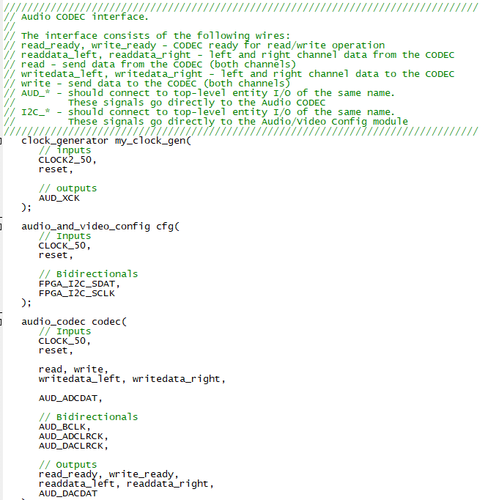

This final project took us two weeks to complete. We enjoyed it and also got really consumed by it. Yet, it is a great experience and thanks for all the hard work this quarter. We have wrote up the comments and suggestions for the final project in the final comment file.